DATA ANALYTICS AND VISUALIZATION
PHASE - 1
Team members:
2503A52948 – Shahanaaz sultana
2503A52949 – Akshaya
2503A52956 – Rishitha
SMART LIBRARY ANALYTICS AND MANAGEMENT SYSTEM
PROJECT OVERVIEW:
The Smart Library Analytics and Management System is a data-driven platform that helps a college or institutional library understand how its resources are used. It converts library usage information into clear summaries and visual reports so that librarians and management can make better decisions about services, collections, digital access and user support.
1.Problem statement:
Many libraries collect information about their users and their reading or borrowing habits, but this information may be stored in separate files or viewed only as raw rows and columns. When data is not analysed properly, it becomes difficult for library staff to understand which groups use the library most, what research areas are in demand, how frequently users access resources, which devices they prefer and whether recommendations are useful.
Problem to be solved: Develop a simple Smart Library Analytics and Management System that organizes library-user data and presents meaningful information through charts, summary cards, filters and reports. It should help library administrators make informed decisions instead of depending only on manual checking or assumptions.
Why this system is needed:
• Raw data is difficult to understand quickly; visual charts make patterns easier to identify.
• Library needs differ across students, faculty, research scholars and library staff.
• Understanding borrowing and access frequency can help staff plan services and resource availability.
• Research-area and department trends can guide collection development and resource recommendations.
• A central dashboard can save time when preparing summaries for library reviews and planning.
Main objective :
To transform library usage data into clear, useful insights that improve resource planning, user experience and the overall management of library services.
2.Users :
The system is designed for people who manage the library and people who use its resources. Each user group needs different information from the system.
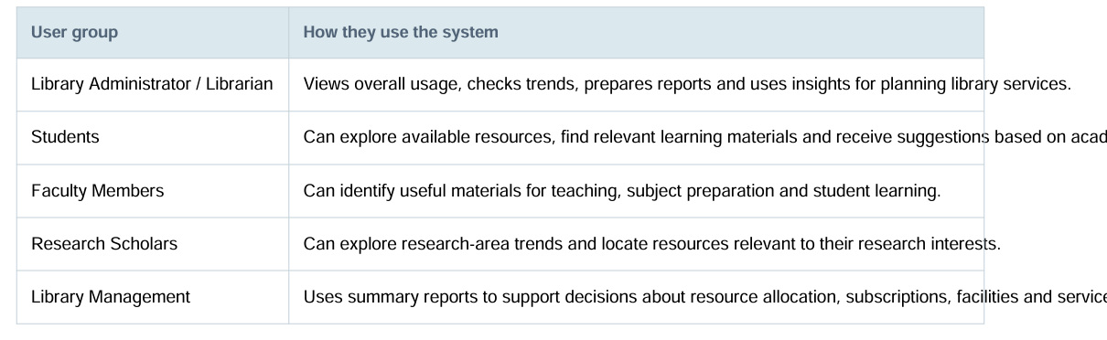
Access control: The librarian/administrator should have permission to view full analytics and manage system settings. Students, faculty and research scholars should see only the services and information permitted for their role. Personal user details should be protected.
3. Expected Features :
The following features describe what the proposed system should provide. The first version can focus on analytics using the supplied dataset; features that require live catalogue, circulation or login data can be added when those data sources become available.
- Dashboard overview :
Displays key information such as total user records, user categories, average reading time, borrowing patterns and recommendation status in summary cards.
- User analysis :
Shows the number and percentage of students, faculty, research scholars and library staff. Helps the librarian understand which groups use library services.
- Department and academic-level analysis :
Compares usage across departments and UG, PG and PhD levels to identify groups that may need additional resources or support.
- Borrowing and access analysis:
Displays borrowing frequency (Rare, Occasional, Frequent and Very Frequent) and access frequency. Helps identify how actively resources are used.
- Research-area analysis:
Highlights popular research interests such as Machine Learning, Data Science, Cyber Security, IoT and other areas in the dataset.
- Reading-time analysis:
Summarises average reading time and can compare reading patterns across user types, departments or academic levels.
- Device and language analysis:
Shows whether users prefer mobile, laptop, desktop or tablet access, and which languages are preferred. This can guide digital-library design.
- Recommendation status :
Shows accepted and rejected recommendation counts and percentages. This helps evaluate recommendation usefulness; it does not by itself explain why a user accepted or rejected an item.
- Search and filters :
Allows authorised users to filter results by user type, department, academic level, research area, language and device type.
- Reports and export :
Allows the librarian to create and download summary reports for meetings, planning and academic reviews.
- Secure role-based access:
Uses login and permissions so that users can access only the features and information appropriate to their role.
- Future library operations integration :
Can later connect to a live book catalogue, book issue/return records, due dates, reservations and stock information. These cannot be reliably displayed from the current dataset alone.
4:Expected Dashboard:
The dashboard should open with a clean overview screen. At the top, show the project name and navigation menu. Under it, display KPI cards. The centre area should contain charts for user types, device preferences and research areas. A filter panel should allow the librarian to narrow the results. A reports area can provide an export option.
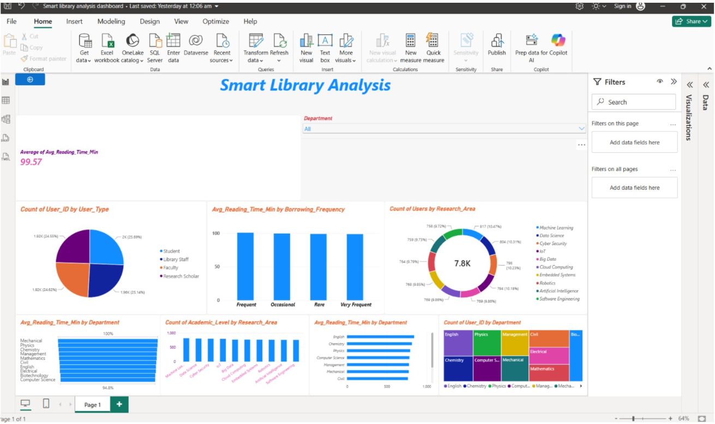
Expected outcome:
A user-friendly, secure and visually clear library analytics dashboard that helps librarians understand user behaviour, identify resource interests, monitor usage patterns and make better data-supported decisions.

